**CO2 Enhanced Oil Recovery (EOR)**

Of these, the market for CO2 in Enhanced Oil Recovery (EOR) warrants highlighting. Interestingly, flooding an oil reservoir with CO2 decreases the viscosity of trapped oil and increases the volume of recoverable reserves (increases yield) with no new exploration and low marginal infrastructure costs. Capturing *industrial emissions* for CO2-EOR reduces GHG releases at the source and creates a profitable incentive for carbon capture use and storage (CCUS) in depleted oil reservoirs.

Lowering the ‘Cost of Capture’ (creating profitable carbon capture) offers a market driven incentive for GHG reduction without the need for government subsidies. Increasing recoverable oil reserves (with no new exploration) offers implicit benefits in reducing oil imports and increasing a nation’s energy security. Thus CO2-EOR is an important market driving research and commercial interests in carbon capture.

**CO2 – EOR = Profitable, Market Incentive for GHG Reduction**

* + Increasing oil yields creates a demand for CO2
  + >$2 Billion *Annual* Global Market (sale of CO2 for EOR)
  + Capturing CO2 from Industrial Emissions reduces GHG releases at the source.
  + Selling this Captured CO2 creates a revenue stream from a waste.
  + Using the CO2 in EOR supports sequestering large volumes of CO2 in depleted reservoirs.
  + Cost-efficient Capture creates a market driven incentive for GHG reduction,

without the need for government incentives (carbon markets are a profit plus, not a necessity).

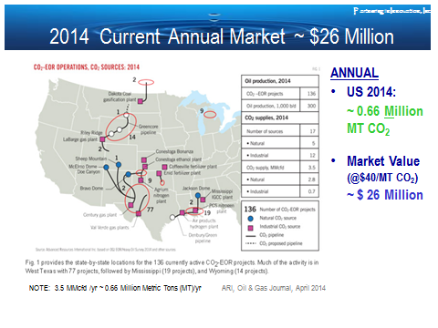There are currently about 100 CO2-EOR projects in the US (IEA, 2009); the majority of these use natural sources of CO2 (e.g., natural accumulations of CO2 in geologic structures). These natural sources are limited in both supply and location. The world is looking toward capturing industrial sources of CO2 to simultaneously increase global oil reserves and reduce GHG emissions.

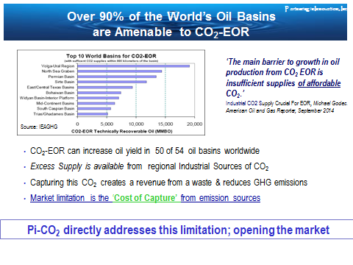 Over 90% of the world’s oil basins are amenable to enhanced recovery using CO2 captured from industrial and natual gas production emissions. ARI (2010) estimates that over 880 Billion barrels of oil (bbl) can be recovered using CO2. This represents a substantial increase in global oil reserves. Increasing yield from known, well characterized reservoirs, it also represents a very high value proposition for the oil industry.

ARI Oil & Gas Journal, April 2014

A 2009 IEA Report, estimates a demand for as much as 140 Gigtonnes (140 Billion Metric Tons) CO2 in the world’s oil basins with the highest EOR potential.

Similarly, ARI estimates that approximately 1.3 Trillion barrels of oil can be recovered using CO2-EOR in known, already characterized basins. Assuming a CO2 sales price of USD $40/Metric Ton, this gives a global market value of $4.8 Trillion.

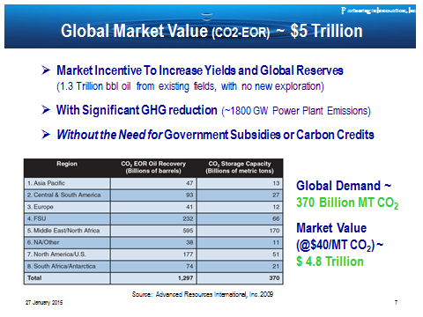

In the US alone, recent ARI estimates suggest that:

* domestic reserves could be increased by 100 Billion barrels of oil with no new exploration,
* using up to 33 Billion metric tons of CO2, and
* creating a $1.3 Trillion domestic CO2 market demand.

**Feasible in Both Low & High Oil Price Markets** It is interesting to note, that these benefits hold in times of high and low oil prices. In times of low oil prices, expensive (and risky) new exploration is curtailed but yields can still be increased with lower capital investments in enhanced oil recovery. In times of high oil prices, the marginal value of each barrel from existing fields creates an incentive for EOR investment.



**Demand for CO2 in the top ten basins ranked by EOR potential.**

Source: IEA Greenhouse Gas R&D Programme (IEA GHG), “CO2 Storage in Depleted Oilfields: Global Application Criteria for Carbon Dioxide Enhanced Oil Recovery, 2009/12, December 2009”.

**Global CO2 Demand ~140 Gigatonnes**

**@ $40/tonne = $5.6 Trillion Market Value**

Using CO2 from industry emissions supports the achievement of multiple sub-goals including:

* creating a clean, market-driven mechanism for reducing greenhouse gas (GHG) emissions;
* increasing oil energy reserves - supporting price stability, economic surety, and international security;
* reducing the need for costly and high risk exploration of new oil and gas reserves thereby protecting wilderness and offshore tracts from exploration and development; and
* creating carbon-neutral ‘green oil’ that results in no net GHG release when that volume of oil is combusted.

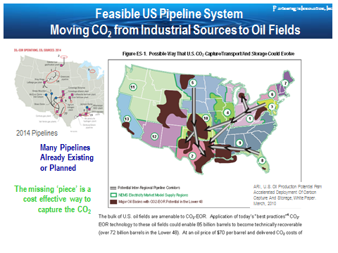 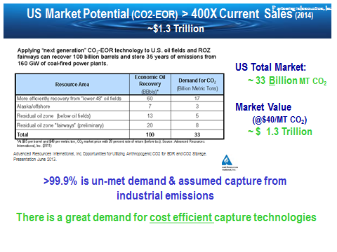

Advanced Resources International (ARI). Opportunities for Utilizing Anthropogenic CO2 for EOR and CO2 Storage. Presentation June 2013.

Current U.S. tax structures offer a $10/metric ton benefit to the oil industry for the use of CO2 in EOR. In areas with an active carbon market, carbon credits offer yet another financial incentive.

In a 2011 report suggesting further incentives, the US National Enhanced Oil Recovery Initiative (www.neori.org) states*: ‘Our analysis indicates that federal revenues from incremental CO2-EOR production would exceed the fiscal cost of new incentives by more than $100 billion over 40 years… this tax credit would result in the production of an additional 9 billion barrels of American oil over 40 years, quadrupling CO2-EOR production and displacing U.S. oil imports… At the same time, the proposed incentive would save the United States roughly $610 billion in expenditures on imported oil, while storing ap­proximately 4 billion tons of CO2 captured from indus­trial and power plant sources, thereby reducing total U.S. CO2 emissions in the process.’*

In recent testimony to the US House of Representatives Subcommittee on Energy (July 23, 2013), Judy Greenwald, Vice President for Technology and Innovation, Center for Climate and Energy Solutions ([www.c2es.org](http://www.c2es.org)) states: *‘According to the National Energy Technology Lab, using existing techniques, CO2-EOR could double or triple U.S. oil reserves and store 10 to 20 billion tons of CO2, which is equivalent to between five and 10 years of emissions from all U.S. coal-fired power plants. More advanced techniques could yield much higher oil production and CO2 storage.’* Given the value proposition and industry support, future incentives may further stimulate growth in this market. However, the financial projections in this plan assume no incentives.